Chemistry II Name: ______________________________

Alkane, Alkene, and Alkyne Nomenclature

For the following organic compounds, name them appropriately.

1. 



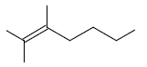

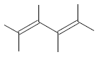

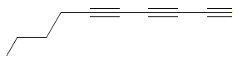

1. 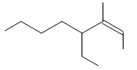

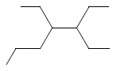

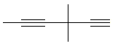

1. 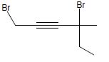
2. 
3. 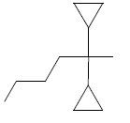

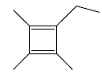



1. 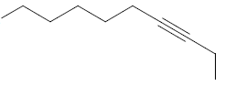



Draw the line structures for the following organic molecules.

1. pentane
2. methane
3. heptanes
4. 3-heptyne
5. ethyne
6. 1-butyne
7. 1,2-hexadiene
8. 1,4,7-octatriyne
9. 1,1-diiodopentane
10. 3-ethyl-1-fluoro-4,5-dimethylhexane
11. 1,1-diiodo-2-methylcyclopropane
12. 1-butyl-1-cyclopentene
13. 6,6-dichloro-4-cyclobutyl-4-methyl-2-hexyne
14. 4-propylheptane
15. 6-methyl-3-heptyne
16. cis-2-hexene
17. trans-4-methyl-2-heptene