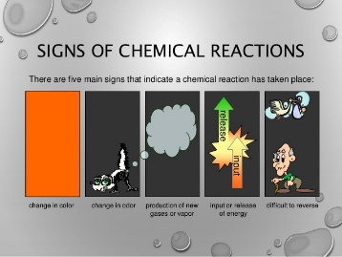
- Signs of a Chemical Reaction
  - Change in color
  - Change in odor
  - Production of new gases or vapor
  - Input or release of energy
  - Difficult to reverse
- Chemical Equations
  - Depict the kind of reactant and products and their relative amounts in a reaction.
  - The letters in () stand for the physical state the atoms/compounds are in.
    - (s) – solid
    - (l) – liquid
    - (g) – gas
    - (aq) aqueous solution
  - The numbers in the front are called stoichiometric coefficients.
    - A stoichiometric coefficient indicates how many:
      - Atoms/compounds of each reactant/product
        - (4 Al atoms + 3 O₂ molecules yield 2 compounds of Al₂O₃)
      - How many moles of each reactant/product
      - IT DOES NOT DIRECTLY TELL HOW MANY GRAMS THERE ARE
  - Chemical Equations must obey the Law of Conservation of Matter
    - Because the same atoms are present in a reaction at the beginning (reactants) and at the end (products), the amount of matter in a system does not change.
    - Therefore, we must balance equations.
  - Why do we care about balancing equations?
    - Provides qualitative information about the identities and physical states of the reactants and products
    - Provides quantitative information because it tells the relative amounts of reactants and products consumed or produced in the reaction.
  - Characteristics of Chemical Equations
    - The equation must represent known facts.
    - The equation must contain the correct formulas for the reactants and products.
    - The law of conservation of mass must be satisfied.
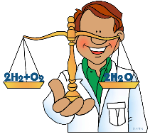
    - Reactants go on the left side and they are substances that exist before a reaction takes place.
    - Products go on the right side and they are the new substances that are formed due to the reaction.
    - An arrow is drawn between reactants and products to represent the reaction taking place (yields).
  - Method for balancing chemical equations
    - Identify the most complex substance.
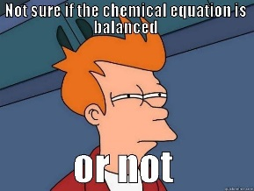
    - Beginning with that substance, choose an element that appears in only one reactant and one product.
    - Adjust the coefficients to obtain the same number of atoms of this element on both sides.
    - Balance the polyatomic ions (if present) as a unit.
    - Balance the remaining atoms, usually ending with the least-complex substance
    - Count the number of atoms of each kind on both sides of the equations to be sure that the chemical equation is balanced.
  - When doing reaction word problems, keep the following in mind:
  - make sure that chemical formulas are accurate in equation
    - Note: Diatomic Molecules - elements that exist in nature in pairs - H₂, N₂, O₂, F₂, Cl₂, Br₂, I₂
  - Example: Write a balanced equation for the reaction between chlorine and sodium bromide to produce bromine and sodium chloride.
  - Example: Write the balanced equation for the reaction between aluminum sulfate and calcium chloride to form a white precipitate of calcium sulfate.
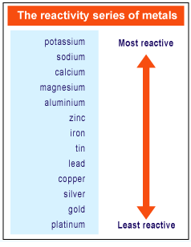
- Types of Chemical Reactions (5 types)
  - Synthesis - A direct combination of two reactants.
    - 2 reactants = 1 product
    - General Form: A + B --> AB
  - Decomposition Reaction - when a more complex reactant becomes two or more products.
    - 1 reactant --> 2+ products
    - General Form: AB --> A + B
  - Single Replacement - when an element reacts with a compound and a new compound is formed and the compound releases one of the elements.
    - 2 reactants --> 2 products
    - General Form: A + BC --> AC + B
    - Activity Series - predicts the outcome of single replacement reactions
      - Any element will reduce compounds of the elements below it in the series.
  - Double Replacement - when two compounds switch their cations to form two or more new compounds.
    - these include acid-base reactions
    - 2 reactants --> 2+ products
    - General Form: AB + CD --> AD + BC
  - Combustion - when a compound burns in the presence of oxygen, producing energy in the form of heat and light.
    - The combustion of organic compounds produces carbon dioxide and water.
    - 2 reactants --> 2 products
    - General Form: organic + O₂ --> CO₂ + H₂O
- Construct Classifying Reactions Flow Chart Here:

