- The mol and compounds
  - molar mass: the mass of one mole of a substance
    - Example: Water's molar mass is 18g / 1 mol
  - Steps to find molar mass:
    - Write out atomic symbols for each element
    - Put how many atoms of each element you have
    - Put the atomic mass of the elements
    - Multiply step ii by iii
    - Add all of the products together
  - Percent Composition - the mass percentage of each element in a compound
    - % of element = (mass of element/molar mass of compound) x 100
  - Empirical Formulas - the smallest ratio of elements that are in a compound
    - Example: C₆H₆ --> CH (empirical formula)
    - C₂H₂ --> CH (empirical formula)
    - How to find an Empirical Formula from Experimental Data
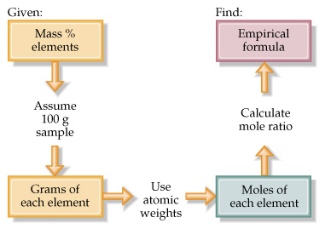
      - Find the number of grams of each element
      - Convert each number of grams to mols
      - Divide each "number of mols" by the smallest "number of mols"
      - Use ratio to find formula
        - the number you come up with tells you how many atoms of each element you have
      - Example: A compound is 45.5% yttrium and 54.5% chlorine. Find its empirical formula.

  - Molecular Formulas - the actual ratio of elements that are in a compound
    - Example: C₆H_{6 (molecular formula)} --> CH _{(empirical formula)}
    - C₂H_{2 (molecular formula)} --> CH _{(empirical formula)}
    - How to find Molecular Formula from Experimental Data
      - Find empirical formula
      - Find molar mass of empirical formula
      - Find n = mm molecular / mm empirical
      - Multiply all parts of empirical formula by n
      - Example: A carbon/hydrogen compound is 7.7% hydrogen and has a molar mass of 78g. Find its molecular formula.

  - Hydrates and Anhydrous Salts
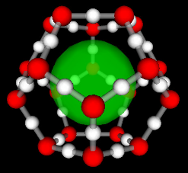
    - anhydrous salt: an ionic compound (a salt) that attracts water molecules and forms loose chemical bonds with them; symbolized by "MN" (metal-nonmetal)
      - "anhydrous" means without water
      - Uses: desiccants in leather goods, electronics, and vitamins (to keep leather dry)
    - hydrate: an anhydrous salt with the water attached
      - symbolized by MN . ? H₂O
      - Examples: CuSO₄ . 5 H₂O, BaCl₂ . 2 H₂O, FeCl₃ . 6 H₂O

    - Finding the Formula of Hydrate
      - Find the number of grams of MN and number of grams of H₂O
      - Convert grams to mols
      - Divide each number of mols by the smallest number of mols.
      - Use the ratio to find the hydrate's formula.
      - Examples: Find the formula of the hydrate from the following information:
        - sample's mass before heating = 4.38g (MN . H₂O)
        - sample's mass after heating = 1.93g (MN)
        - molar mass of anhydrous salt = 85g
- Stoichiometry involves finding the amounts of reactants and/or products in a chemical reaction.
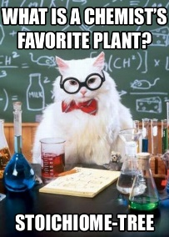
  - Why is Stoichiometry important? Consider the following examples:
    - Internal Combustion Engine:
      - Balance the following equations:
        - ____C₈H₁₈ + ____O₂ -----> ____CO₂ + ____H₂O
        - ____C₈H₁₈ + ____O₂ -----> ____C + ____H₂O
        - What is the difference?
  - Basic Chemical Equation: R_{A} + R_{B} ---> P₁ + P₂
    - If we know the: One can find the...
      - Amount of R_{A} (or R_{B}): The amount of the other reactant needed to react
      - Amount of R_{A} or R_{B} : Amount of P₁ or P₂ that will be produced
      - Amount of P₁ or P₂ : Amount of R_{A} and/or R_{B} you need to produce must use
  - Calculations in Stoichiometry - Mol Island
    - There are four conversion you will need to know
      - molar mass (g/mol)
      - Avogadro's Number (6.02 x 10²³ particles/mol)
      - Volume (22.4 L/mol @ STP)
      - Mol-Mol Ratio (between reactants and/or products)
        - This comes from the balanced chemical equation

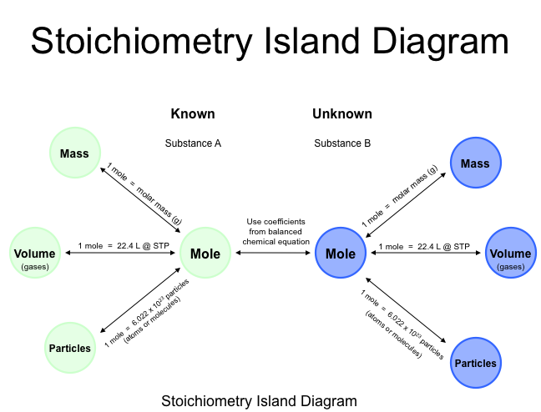
    - Examples: ___ Cu + ___ AgNO₃ --> ___ Ag + ___ Cu(NO₃)₂
      - If you have 300g of AgNO₃, how many grams of copper nitrate would be produced?

    - ___ TiO₂ + ___ Cl₂ + ___ C --> ___ CO₂ + ___ CO + ___TiCl₄
      - If you have 115 grams of titanium oxide, how many particles of titanium chloride would be produced?

      - If you have 4.55 mols of carbon, how many mols of chlorine gas will be needed?

  - Limiting Reactant (LR): the reactant that runs out first.
    - the amount of product is based on the LR
    - Any reactant you don't run out of is an excess reactant (ER).
    - How do we find the limiting reactant?
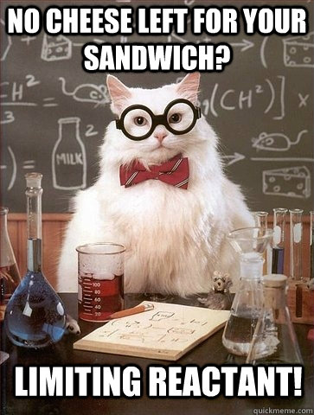
      - For the generic reaction, R_{a} + R_{B} --> P₁
      - Assume that the amount of R_{a} or R_{b} are given
      - Should you use R_{a} or R_{b} in your calculations?
      - Calculate the number of mols of R_{a} and R_{b} you have.
      - Divide by the respective coefficients in balanced chemical equation.
      - Reactant having the smaller result is the LR.
      - Example: If 125g of aluminum reacts with 125g of chlorine, how many grams of aluminum chloride is made?

  - Percent Yield
    - Let's consider the following reaction: molten sodium reacts with solid aluminum oxide to produce molten aluminum and solid sodium oxide
      - Find mass of aluminum produced if you start with 575g of Na and 357g of aluminum oxide.
    - The amount of product is the theoretical yield.
      - amount of product if reaction is perfect
      - found by calculation
    - Now supposed that we perform this reaction in the lab and only got 172 grams of aluminum.
      - Why did this happen?
        - couldn't collect all Al
        - not all Na and Al₂O₃ reacted
        - some reactant or product spilled and was lost
    - Percent Yield - percentage of product that was produced
      - % yield = (actual yield / theoretical yield) x 100
      - % yield cannot be larger than 100%
      - Example: B₂H₆ + 3 O₂ --> B₂O₃ + 3 H₂O
        - If you have 10g of B₂H₆ and 30g of oxygen, how many grams of B₂O₃ would be produced?

        - If only 19.7g of B₂O₃ was produced, what was the percent yield?

