What are Reduction-Oxidation Reactions?

These are special reactions that occur when there is a transfer of electrons

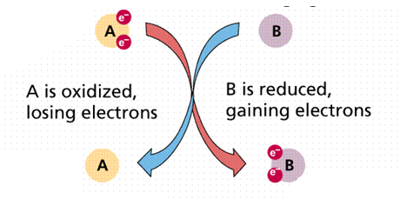
Oxidation involves a loss of electrons

Reduction involves a gain of electrons

So why care?

The rusting of metal

The process involved in photography

The way living systems produce and utilize energy

The operation of a car battery

So, to start I want you to learn this statement!

LEO the lion goes GER when he picks up the CRAyOn off the student’s LAP with EFFORT and throws it in the VAN

LEO –Lose Electrons Oxidation

GER – Gain Electrons Reduction

CR – Cathode, reduction occurs

AyOn – Anode, oxidation occurs

LAP – Electrolytic cell Anode Positive

VAN – Voltaic cell Anode Negative

EFFORT- Electrons flow from oxidation to reduction

Oxidation Numbers

Before discussing redox reaction, we must first look at oxidation numbers

Oxidation numbers or Oxidation States are used to indicate the general distribution of electrons in a molecule or ion

NOTE: Charges and oxidation states are different.

A charge is a physically real characteristic

Oxidation numbers are “bookkeeping” devices to keep track of the overall electron distribution and ARE NOT actual physical characteristics of atoms

Assigning Oxidation Numbers

Rule #1 - The oxidation number for a free element is ALWAYS zero

Example:

Oxidation number of Na_{(s)} is zero

Oxidation number of H_{2(g)} is zero

Rule #2 - The oxidation number of a monatomic ion equals the charge of the ion.

Example:

Oxidation number of Cl⁻ is -1

Oxidation number of Mg²⁺ is +2

Rule #3 - The oxidation number of hydrogen in a compound is usually +1 except in hydrides where it is -1

Example:

Oxidation number of hydrogen in HCl is +1

Oxidation number of hydrogen in NaH is -1

Rule #4 - The oxidation number of oxide and sulfide in compounds is usually -2.

Example:

Oxidation number of oxide in H₂O is -2

Oxidation number of sulfide in Na₂S is -2

Rule #5 - The oxidation number of elements in group I in a compound is +1

Example:

Oxidation number of potassium in KI is +1

Oxidation number of lithium in LiCl is +1

Rule #6 - The oxidation number of elements in group II in a compound is +2

Example:

Oxidation number of calcium in Ca(OH)₂ is +2

Oxidation number of barium in BaCl₂ is +2

Rule #7 - The oxidation number of aluminum in a compound is usually +3

Example:

Oxidation number of aluminum in AlCl₃ is +3

Rule #8 - The oxidation number of fluoride in a compound is ALWAYS -1

Example:

Oxidation number of fluoride in HF is -1

Oxidation number of fluoride in LiF is -1

Rule #9 - The oxidation number of the halogens (group 17/VIIA) in a compound is -1 except…

Fluorine is ALWAYS a -1When bonded to oxygen, nitrogen or another halogen

Example:

Oxidation number of chloride in AlCl₃ is -1

Oxidation number of bromide in NaBr is -1

Rule #10 - The sum of the oxidation numbers of all the atoms in a neutral compound is 0.

Example:

AlCl₃

Aluminum is +3

Chloride is -1 X 3 so total -3

So, +3 and -3 make the compound neutral

Rule #11 - The sum of the oxidation numbers in a polyatomic ion is equal to the charge of the ion.

Example:

OH⁻

Oxygen is -2

Hydrogen is +1

So, -2 and +1 make the ion have a charge of 1-

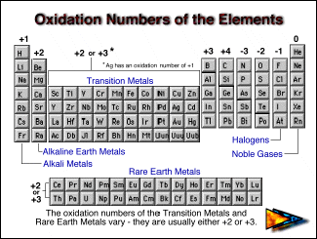

Problem solving method

Assign oxidation state to atoms that have a known number

Fluoride

Halogens

Oxide and sulfide

Hydrogen

Group 1

Group 2

Aluminum

Assign other oxidation numbers to the other atoms remembering….

If it is a compound, it must be neutral

If it is an ion, then there is an overall charge

Oxidation- is the process in which an atom or ion loses electrons

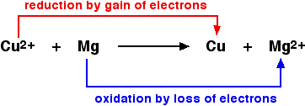
Example:

Na → Na⁺ + e⁻

Cu  Cu²⁺ + 2e⁻

Note: Electrons are products

GER- Gaining electrons

Reduction- is the process in which atoms or ions gain electrons

Examples:

Cl₂ + 2e⁻ → 2Cl⁻

Br₂ + 2e-  2Br⁻

Note: Electrons are reactants

Examples

Identify the following half reaction as either an oxidation or reduction half reaction.

2 I⁻ → I₂ + 2e⁻

Cl₂ + 2e⁻→2 Cl⁻

Fe  Fe²⁺ + 2e⁻

Fe³⁺ + e⁻  Fe²⁺

For the following reaction, indicate which element is oxidized and which is reduced

Start with the oxidation numbers

H_{2(g)} + CuO_{(s)} → Cu_{(s)} + H₂O_{(l)}

H_{2(g)} + Cl_{2(g)} → 2HCl

Electrochemistry is the branch of chemistry that deals with electricity-related applications of oxidation-reduction reactions

These reactions usually take place in an electrochemical cell.

There are two types of electrochemical cells: Voltaic (also known as galvanic) and Electrolytic

A voltaic cell is an electrochemical cell where a redox reaction occurs naturally and produces electrical energy

An electrolytic cell is an electrochemical cell where a redox reaction requires electric energy to occur

So, what is the same about these cells?

Both cells have electrodes

An electrode is a conductor in a circuit that carries electrons

The electrode where reduction occurs is the CATHODE

The electrode where oxidation occurs is the ANODE

Just remember CRAyOn

Let’s look at each cell more specifically

Voltaic cells

These cells occur naturally or spontaneously

We will look at potentials to determine when a reaction is spontaneous but let’s look at a cell first

Let’s look at the reaction between zinc and copper.

Zinc and copper are electrodes

The zinc is in a solution of ZnSO₄

The copper is in a solution of CuSO₄

Zn_{(s)} → Zn²⁺_{(aq)} + 2e⁻

Cu²⁺_{(aq)} + 2e⁻ → Cu_{(s)}

Let’s identify

Which reaction is oxidation?

Which reaction is reduction?

the anode?

the cathode?

the positive metal?

the negative metal?

Electrolytic cell

Let’s look at the reaction between iron and silver.

Iron and silver are electrodes

The electrodes are in a solution of Fe(NO₃)₃

Fe³⁺_{(aq)} + 3e⁻ → Fe_{(s)}

3Ag_{(s)} → 3Ag⁺_{(aq)} + 3e⁻

Let’s identify

Which reaction is oxidation?

Which reaction is reduction?

the anode?

the cathode?

the positive metal?

the negative metal?

