- Solution - a homogeneous mixture
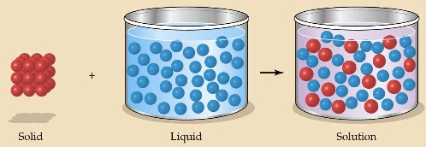
  - evenly mixed at the particle level
    - Ex: salt water
  - Alloy - a solid solutions of metals
    - Ex: bronze = Cu and Sn; brass = Cu and Zn
  - Solvent - the substance that dissolves the solute
    - Water Salt
  - Soluble - "will dissolve in"
    - Ex: Salt will dissolve in water
  - Miscible - refers to two gases or two liquids that form a solution
    - This is more specific than soluble
    - Ex: food coloring in water

- Factors affecting solution formation
  - temperature
    - As temperature increases, the rate increases
    - As temperature decreases, the rate decreases
  - particle size
    - As particle size increases, the rate decreases
    - As particle size decreases, the rate increases
  - Mixing
    - As mixing increases, the rate increases
    - As mixing decreases, the rate decreases
  - The nature of solvent and/or solute

- Classes of Solutions
  - aqueous solution - solvent is water (H₂O)
    - water = "the universal solvent"
  - amalgam - solvent is mercury (Hg)
    - Ex: dental amalgam (Hg + Sn + Ag)
  - tincture - solvent is alcohol
    - Ex: tincture of iodine (for cuts)
  - organic solution - solvent contains carbon
    - Ex: gasoline, benzene, toluene, hexane

- Non-Soluble Definitions
  - insoluble - "will not dissolve in"
    - Sand will not dissolve in water
  - immiscible - refers to two gases or two liquids that will NOT form a solution
    - Ex: water and oil
  - suspension - appears uniform while being stirred, but settles over time
    - Ex: orange juice

- Molecular Polarity
  - non-polar molecules - electrons are shared equally and tend to be symmetric
    - Ex: Fats and Oils
  - polar molecules - electrons are not shared equally
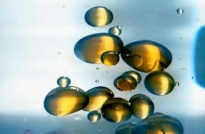
    - Ex: water
  - "Like dissolves Like"
    - polar + polar = solution
    - nonpolar + nonpolar = solution
    - polar + nonpolar = suspension (won't mix evenly)

- Applications of Solubility Principles
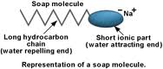
  - Chemicals used by body obey solubility principles
    - water-soluble vitamins: Vitamin C
    - fat-soluble vitamins: Vitamins A and D
  - Dry Cleaning employs non-polar liquids
    - polar liquids damage wool and silk
    - also, dry cleaning removes ink, rust, and grease
    - they use tetrachloroethylene
  - Emulsifying Agent (emulsifier):
    - molecules with both a polar AND a nonpolar end
    - allows polar and nonpolar substances to mix
    - Examples:
      - soap -made from animal and vegetable fats
      - detergent -made from petroleum
        - works better in hard water
    - Model of a soap molecule
      - Hard water contains minerals with ions (Ca²⁺, Mg²⁺, and Fe³⁺ that replace Na¹⁺ at polar end of soap molecule.
      - Soap is then changed from an emulsifier into an insoluble precipitate (soap scum)
- Solubility Curves
  - Solubility - how much solute dissolves in a given amount of solvent at a given temperature
    - It is a general rule is that the solubility of solids increases with increasing temp.
    - Solubility is expressed as:
      - the mass of solute per volume - (g/L)
      - the mass of solute per mas of solute - (g/g)
      - the mols of solute per volume - (mol/L)

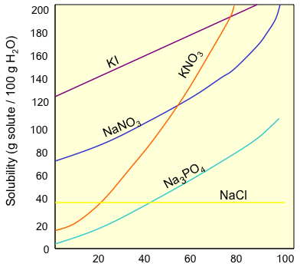
- Saturation Terms
  - Saturated - A solution that contains the maximum possible amount of solute
  - Unsaturated - If a solution contains less than the maximum amount of solute
  - Supersaturated - when a solution is prepared at a higher temperature and then allowed to cool, there is more solute then its saturation point

- Solubility of Gases
  - Gases have the opposite relationship between temp and solubility
  - As temperature increases, the solubility decreases
  - Example: Which goes flat first: a cold pop or a warm pop.

- Concentration - a measure of solute-to-solvent ratio
  - concentrated - "lots of solute"
  - dilute - "not much solute", "watery"
  - Concentration Units
    - mass % = mass of solute/mass of solvent
    - parts per million (ppm) - commonly used for minerals or contaminants in water supplies
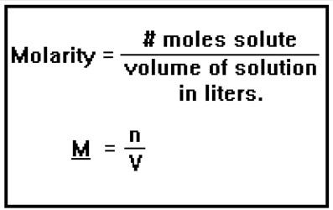
    - molarity (M) = moles of solute/liters of solution
      - Ex: what I use, what is commonly used in class
  - Example: How many mols of solute are required to make 1.35 L of 2.50 M solution?
    - Example: Find the molarity of 58.6g of barium hydroxide {Ba(OH)₂} that are in 5.65 L of solution.

- Dilutions of Solutions - acids and bases are purchased in concentrated form and must be diluted to desired concentrations.
  - Dilution Equation: M_{c}V_{c} = M_{D}V_{D}
    - M = molarity C = Concentrated V = Volume D = Diluted
  - Example: Concentrated H₃PO₄ is 14.8 M. What volume of concentrate is required to make 25.0 L of 0.5 M H₃PO₄?

