History of the Development of the Atomic Model
- The first civilization that looked into the Atom is the Greeks
  - ~400 B.C.E.
  - Greeks tried to understand matter and broke matter into four groups:
    - Fire: Earth: Air: Water
  - Democritus - Greek Philosopher
    - came up with the idea of "atomos"
      - Atomos = 'indivisible'
      - 'Atom' is derived
    - No experiments to support idea
    - No protons, electrons, or neutrons but a solid that was indestructible
    - Quote from Democritus: "To understand the very large, we must understand the very small."
- Aristotle - around 340 B.C.E.
  - Another Greek philosopher
  - Did not believe in the theory of atoms
  - Thought that the idea of not being able to break down atoms any further would be putting a restriction on the Gods
- After the Greeks, Chemistry was ruled by alchemy.
  - during this time, several elements were found
  - equipment, procedure, and experimental techniques improved
- Robert Boyle - 17th century - wrote the book "Skeptical Chemist"
  - In his book he stated: “A substance was an element unless it could be broken down to two or more substances.”
  - Air therefore could not be an element because it could be broken down it to many pure substances.
  - This supported Democritus' thoughts on the atom and began the end of the thoughts of the mystical makeup of matter
  - Stated that the term element needs a more precise meaning.
    - Earth can’t be an element because gold, mercury, iron, and many others come from the Earth
- John Dalton's Atomic Theory – 1808
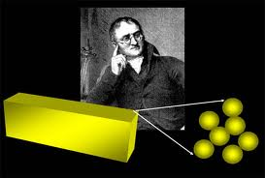
  - Elements are made of indivisible particles called atoms
  - Atoms of the same element are exactly alike, including having the same mass
  - For example: this gold bar can only be divided to the point that you end up with pieces (spheres) of gold that can no longer be divided.
    - Note: John Dalton was the first scientist to have evidence to support his atomic model.
- Sir John Joseph Thomson – 1897
  - Found that electrons can be stripped off of metal atoms
  - The glass tube was stripped of most of its air
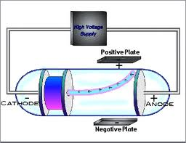
  - An electron beam was shot from one side of the tube to the other
  - It was found that the positive and negative plate could influence the direction of the beam
  - He found that the particles that were bent were a couple thousand times lighter than the hydrogen atom (1 proton)
  - Conclusions from the experiment:
    - Particles had been stripped off (means that atoms are divisible)
    - This was the discovery of the electron
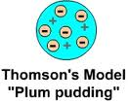
    - Electrons had a very small mass
- William Thomson (a.k.a. Lord Kelvin)
  - Since atom was known to be electrically neutral, he proposed
the plum pudding model.
  - Equal quantities of + and – charges
  - Charges evenly distributed in atom
  - + is 2000 times bigger than –
- Robert Millikan (1909) – Oil Drop Experiment
  - experiment to determine the electric charge of an electron
  - The experiment entailed observing tiny charged droplets of oil between two horizontal metal electrodes.
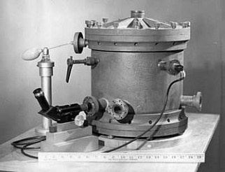
  - Oil droplet’s terminal velocity was measured, which means that gravity and drag are equal, therefore the mass could be determined.
  - Knowing the mass and gravitational pull, a known electric field was applied and the oil droplets were suspended to where they were at mechanical equilibrium meaning their electrical force equaled their gravitational force.
  - From this they found the charge of oil droplets and they were always some multiple of 1.5924×10⁻¹⁹ C, about 0.6% difference from the currently accepted value of 1.602176487×10⁻¹⁹ C.
  - They proposed that this was the charge of a single electron.
- Ernest Rutherford (1909) - Gold Leaf Experiment
  - A radioactive source emitted alpha particles ( a positively charged particle) that shot out in one direction towards a thin sheet of gold foil.
  - It was found that most of them passed right through the foil like it wasn't there.
  - Surprisingly, occasionally, an alpha particle would hit the screen off to the side and some even bounced backwards.
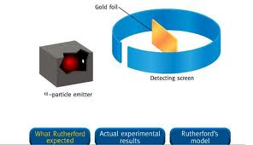
  - Conclusions from his experiment
    - The positive proton was not spread out over the whole atom
    - Almost the entire mass of the atom was in a tiny area in the center (nucleus = 1/100,000 radius of atom)
    - Therefore, the fast-moving alpha particle would usually miss the tiny nucleus
    - If it did get real close, it would be pushed away by the positive repulsion of the protons in the nucleus.
    - The negatively charged particles (electrons) orbit the nucleus
- James Chadwick (1932)
  - Chadwick joined Rutherford in research after being a POW during WWI
  - Chadwick’s researched focused on radioactivity
  - As they studied atomic disintegration (radiation), they kept seeing that the atomic number was less than the atomic mass
    - Ex: A helium atom has an atomic mass of 4, but an atomic number (positive charge) of 2
  - One idea was there was 4 protons in the nucleus along with 2 electrons to yield a charge of 2+
  - After studying other researchers (Frederic and Curie), he looked for a particle with no charge and a mass near that of a proton.
  - He was successful and determined the neutron existed and published his findings in a paper entitled "Possible Existence of Neutron."
  - The point of the neutron is for nucleus stability

Recent Atomic Models
- Niels Bohr (1913) - Bohr Model
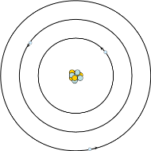
  - Also known as the Planetary Model - electrons follow a set path much like the planets in the solar system
  - Electrons can only possess certain amounts of energy therefore can only be certain distances from the nucleus.
  - Explains how light is emitted from some atoms such as hydrogen
- Louis de Broglie – 1924
  - Found that electrons exhibit wave properties
  - Wavelengths are quantized (meaning that there are only whole numbers involved: no in between)
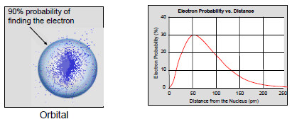
- Werner Heisenberg - 1926
  - Heisenberg Uncertainty Principle
    - States that we never know for certain the velocity or position of an electron at the same time
- Erwin Schrodinger - 1926
  - wave equation of quantum waves
  - only certain solutions, no in between #s
  - quantized energy levels
  - defines probability of finding an electron
- Quantum Mechanical Model (Model that is accepted today)
  - Also known as the electron cloud model
  - Orbital ("electron cloud") - region in space where there is a 90% probability of finding an electron

Basics of the Atom
- The subatomic particles
Particle | Charge | Location in the Atom | Mass

  - 1 u.a.m.u. = 1.66 x 10⁻²⁷ kg
- 7. Properties of the basics of the atom:
  - u.a.m.u. - unified atomic mass unit
    - used to measure the mass of atoms
    - Equal to 1/12 of the mass of an unbound neutral atom of carbon-12 in its ground state.
    - has a value of 1.66 x 10⁻²⁷ kg
  - Atomic Number
    - the number of protons for that element
    - the whole number of Periodic Table
    - determines the identity of atoms
    - change this number, we change the identity of the atom
- Mass Number (Atomic Mass)
  - The number of protons + number of neutrons
  - Protons and Neutron are the only two particles consider to have any mass
  - This number can differ
- Isotopes
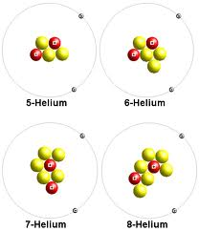
  - Different varieties of the same type of element
  - have different number of neutrons
  - different atomic masses
  - some are radioactive, others are not
  - All atoms of an element react the same way chemically.

- Average Atomic Mass
  - This is the weighted average mass of all atoms of an element that occur in nature and are not radioactive
  - measured in u.a.m.u.
  - To find average atomic mass: (knowing % abundance)
    - You take the mass of an isotope and multiply times the relative abundance (how often it appears in nature)
    - Do the same for all isotopes
    - Add up the sum the numbers found in step a and b
    - AAM = mass A (R.A. of A) + mass B (R.A. of B) + ...........
    - *Round using sig figs
    - Example: Lithium has two isotopes. Li-6 occurs 7.5% of the time while Li-7 occurs 92.5% of the time. What is the average atomic mass of Lithium?

  - To find percent abundance: (knowing weighted average)
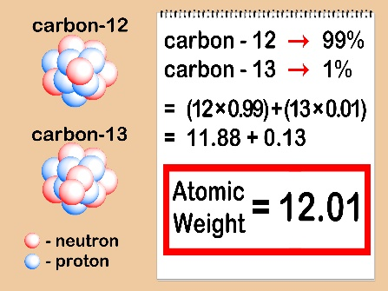
    - You must set one of the % abundances equal to x and the other must be equal to (1-x)
    - Plug in numbers
    - Solve for x
    - The isotope you set equal to x is equal to your answer from iii
      - multiply by 100 to find percentage
    - Solve for the other one by subtracting x from 1
      - multiply by 100 to find percentage
    - AAM = mass A (%A) + mass B (%B)
    - AAM = mass A (x) + mass B (1-x)
    - *Round using sig figs
    - Example: Iridium is composed essentially of two isotopes: Ir-191 and Ir-193. The average atomic mass of an iridium atom is 192.2 uamu. Determine the natural abundance of each of these isotopes in a naturally occurring sample.

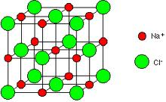
- Ions - a charged atom
  - involves differences in protons and electrons
  - Two types of ions
    - Anion
      - a (-) ion
      - more electrons than protons
      - formed when atoms gain electrons
      - usually found on the right side of the periodic table
    - cation
      - a (+) ion
      - more protons than electrons
      - formed when atoms lose electrons
      - found on the left side of the periodic table

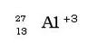
- Complete Atomic Designation
  - Gives precise information about an atomic particle
- The Mole
  - Atoms are so small, it impossible to count them by the dozens, thousands, or even the millions
  - To quantify atoms, we use the concept of the mol
  - A mol of any element is defined as the number of atoms of that element that equal to the number of atoms in exactly 12.0 grams of carbon-12
  - This solved a major issue of going between number of atoms, the u.a.m.u., and mass.
- Avogadro’s Number
  - The number of atoms or compounds in one mol of substance
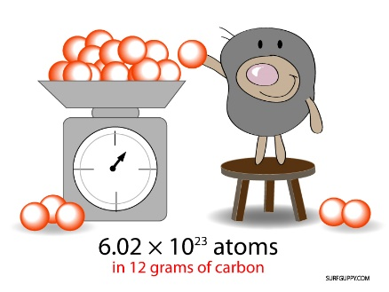
  - Value is: 6.02 x 10²³ items/mol
  - Named in honor of Amedeo Avogadro
  - Found by other scientists
  - Millikan was first to accurately measure it
  - X-ray technology today supports value
  - For any element on the Periodic Table, one mol of that element (i.e., 6.02 x 10²³ atoms of that element) has a mass in grams equal to the atomic mass on the Table for that element.
    - Example: 1 mol C-12 = 6.02 x 10²³ atoms of C = 12 g C
- To solve problems where we go between mass, atoms, and moles, we must use conversion factors.
  - Conversion factors we will be using are:
    - $\frac{1 mol of substance}{6.02 x {10}^{23}items}$
    - $\frac{1 mol of substance}{atomic mass of that substance in grams}$
  - Conversion factors can be flipped, need to figure out what we need to get rid of
  - You will change the unit of atomic mass from u.a.m.u. to grams
  - Example: How many moles is 3.79 x 10²⁵ atoms of zinc?

  - Example: How many grams are in 3.5 x 10²⁶ atoms of Radium?

