Radioactive Isotopes
- Have too many or too few neutrons
- Nucleus attempts to attain a lower energy state by releasing extra energy as radiation.
  - Common forms of radiation include
    - Alpha
    - Gamma
    - Beta
- Half-life - the time needed for 1/2 of a radioactive sample to decay into stable matter
  - The stable matter may have a higher or lower atomic number
  - Useful in dating objects
  - Example: Say that a 120g sample of C-14 is found today. How much will be remaining after 22,920?

- Writing Radiation equations
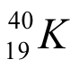

- The Nuclear Symbols for the different types of radiation are:
  - Alpha – helium nucleus – radiation can be stopped by sheet of paper
    - 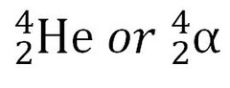
  - Beta – neutron becomes proton – radiation can be stopped by aluminum plate
    - 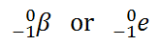
  - Gamma – consists of photons – absorbed by dense materials but goes through most items
    - 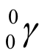
- When writing the equation, start with the radioactive isotope on the left followed by a yield sign. The right side of the equation will consist of the radiation and the more stable isotope.
  - Example 1: Thorium-232 decays by emitting an alpha and a gamma.

  - Example 2: Uranium-239 decays by emitting a beta and a gamma.

