- Quantum Mechanics
  - Using the Quantum Mechanical Model, we can determine the likelihood of finding an electron
  - The Pauli Exclusion Principle states that no two electrons in an atom can occupy the same orbital (they cannot have the same address)
  - There are four quantum numbers that can help us locate each electron in an atom. (find their address)
    - Principle Quantum Number (n)
      - The energy level of the electron
      - Determines the size of the orbital
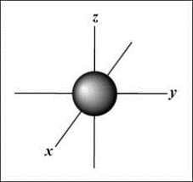
      - Accepted values are n=1,2,3,4,5,6,7.
      - The higher the principle quantum number, the more energy the electron has.
    - Angular Momentum Quantum Number ( l )
      - Tells the energy sub-level
      - Tells you the shape of the orbital
      - Depends upon the principal quantum number
      - n-1 = l --> whatever you get, you also have the previous orbits (4-1 = 3,2,1, and 0)
        - l =0 s orbit
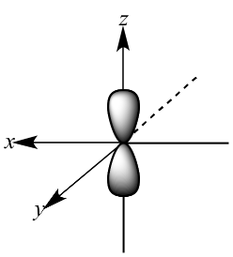
        - l =1 p orbit
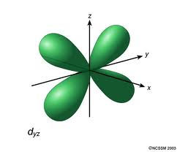
        - l =2 d orbit
        - l =3 f orbit
    - Magnetic Quantum Number (m_{l})
      - Specifies the orientation of a specific orbital
      - Tells you the exact orbital within each sublevel
      - Depends upon the angular momentum quantum number.
      - The pattern is: m_{l} = -l ..., 0, ..., +l
        - Thus, when l = 0, m_{l} = 0
        - when l = 1, m_{l} = -1,0,+1
        - when l = 2, m_{l} = -2,-1,0,+1,+2
        - when l = 3, m_{l} = -3,-2,-1,0,+1,+2,+3
    - Spin Quantum Number (m_{s})
      - Specifies the direction of the spin of an electron
      - Each orbital can only hold 2 electrons that spin in opposite directions (clockwise and counterclockwise)
      - Values for electron spin are +1/2 or -1/2

- Electron Configurations - Electrons follow a set of rules when filling their orbits around a nucleus.
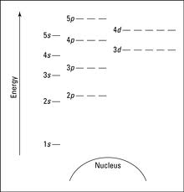
  - Aufbau Principle: Electrons are added one at a time to the lowest energy orbitals available until all the electrons of the atom have been accounted for.
    - 1s, 2s, 2p, 3s, 3p, 4s, 3d, 4p, 5s, 4d, 5p, 6s, etc...
  - Hund's Rule: Electrons occupy equal-energy orbitals so that a maximum number of unpaired electrons results.
  - Pauli Exclusion Principle: An orbital can only hold a maximum of two electrons. To occupy the same orbital, two electrons must spin in opposite directions.
  - Arrows pointing up and down represent electrons spinning in opposite directions
  - When we write out the electron configuration, you indicate how many electrons are in each sub-level with a superscript.

- Shorthand Electron Configuration (Noble Gas Config.)
  - This is yet another way to write electron configurations.
  - This is a shorter, quicker way to write them.
  - To write a S.E.C.
    - Put symbol of noble gas that precedes element in brackets.
    - Continue writing electron config. from that point.

- The Importance of Electrons
  - In an electron configuration: (1s²2s²2p⁶3s²3p⁶...)
    - coefficient --> # of the energy level
    - superscript --> # of electrons in those orbitals
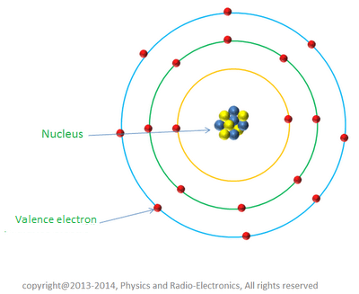
  - In general, as energy level increases, electrons:
    - Have more energy
    - Are further away from the nucleus
  - We categorize electrons into 2 groups
    - Core Electrons
      - These are electrons that are not part of the outer most energy level.
      - These electrons are close to the nucleus.
      - These are not involved in chemical bonds.
    - Valence Electrons
      - The outer most electrons: in the highest energy level.
      - Are involved in chemical bonding
      - The sum of the s and p orbitals in the outer energy level.
  - Space for examples

- The Octet Rule
  - Atoms want to have a full outer energy level.
  - If they do not, they are highly unstable.
  - With the s and p orbitals being the outermost energy levels of an atoms electron configuration, atoms want to fill those two which for most elements that would mean 8 electrons. (s=2, p=6)
  - The octet rule states atoms have the tendency to "want" 8 valence electrons.
  - They want to be like their closest noble gas
  - Exceptions to this rule include H, He, Li, Be, B (their closest noble gas is He and He only has two valence electrons)
    - Known as the duet rule
  - Noble gases atoms have full valence shells. This makes them stable, low-energy, and unreactive.

- The Connection between Electrons and Light
  - When all electrons are in lowest possible energy state, an atom is in the ground state.
    - Ex: He --> 1s²
  - If the right amount of energy is absorbed by an electron, it can "jump" to a higher energy level. This is an unstable, momentary condition called the excited state.
    - Ex: He --> 1s¹2s¹
  - When the electron falls back to a lower-energy, more stable orbital (it might be the orbital it started out in, but it might not), atom releases the "right" amount of energy as light.
  - When light energy is released from different substances, it has been found that the colors emitted are unique to the substance.
  - Emission spectrum - the spectrum of bright lines, bands, or continuous radiation produced by a specific substance.
    - Process of determining the elements is known as spectral analysis
  - Light as a wave
    - Wave - a transfer of energy where no permanent displacement occurs to the medium (air, water, etc...).
    - Wavelength (λ) - length of one complete wave
    - Amplitude (A) - distance from the origin to the trough or crest
    - Crest - Highest Point of the Wave
    - Trough - Lowest Point of the Wave
    - Frequency (f) - # of waves that pass a point during a certain time period
      - hertz (Hz) = 1/s
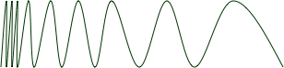
  - Formula connecting f and λ
    - c = f λ
    - c = speed of light 3x10⁸ m/s
    - f = frequency – Hz
    - λ = wavelength – m
    - The energy of light is closely related to its color. High energy light appears purple, low energy light appears red, and intermediate energies of light have intermediate colors such as blue, green, yellow, and orange.
  - Energy and Light
    - The amount of energy from photons is directly related to its frequency.
    - E = h f
      - E = energy (Joules or J)
      - h = Planck's constant (6.6x10⁻³⁴ J/s)
      - f = frequency (1/s)
    - Therefore, the higher the frequency, the higher the energy.
    - The lower the frequency, the lower the energy.
    - Thus, the shorter the wavelength, the higher the energy.
    - Thus, the longer the wavelength, the lower the energy.
    - Max Planck: found that energy is released in packets and not a smooth increase in energy.
  - Light as a Particle --> The Photoelectric Effect
    - Albert Einstein conducted his experiment where he shot different frequencies of light at metal.
    - He found that when you have a large enough frequency, the metal would emit electrons from its surface.
    - When he increased the amount of light at that frequency, it only increased the number of electrons emitted.
    - When he increased the frequency of the light, the electrons that were emitted from the surface moved faster.
    - So, if E=hf, and if f increases, then E increases
    - Einstein therefore came up with:
      - E=mc² which shows that if the energy is increasing, the mass must increase.
      - Einstein claimed that anything with a mass has energy.
      - The famous KE=1/2mv² is only kinetic energy and not all energy.
      - (1905) concluded that light has properties of both waves and particles
        - Wave-particle duality
      - Photon – particle of light that carries a quantum of energy
      - Therefore, E = hf = mc²

  - Examples
    - A certain photon has a wavelength of 422 nm. What is the frequency of the light?

    - What is the energy of the light from the previous problem?

    - What is the energy of a quantum of light with a frequency of 7.39 x 10¹⁴ Hz?

    - What is the wavelength of the light?

