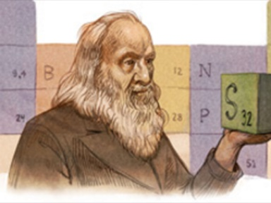
- Dmitri Mendeleev
  - Russian
  - Invented periodic table
  - Organized elements by properties
  - Arranged elements by atomic mass
  - Predicted the existence of several unknown elements
  - Element 101 named in his honor
- Henry G.J. Moseley - 1914
  - Created the modern periodic table using Mendeleev’s periodic table
  - Determined the atomic numbers of elements from their X-ray spectra
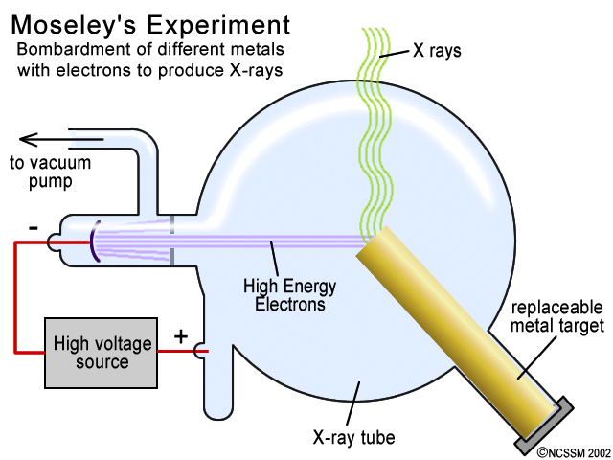
  - Arranged elements by increasing atomic number
- Introduction to the Periodic Table
  - Elements are arranged in seven horizontal rows, in order of increasing atomic number from left to right and from top to bottom
  - Rows are called periods and numbered from 1 to 7
  - Elements with similar chemical properties form vertical columns, called groups or families, which are numbered from 1 to 18
  - Groups 1,2, and 13-18 are the main group elements (Representative Elements)
    - s and p orbitals
  - Groups 3 -12 are in the middle of the periodic table and are known as the transitions elements.
    - d orbital
  - The two rows of 14 elements at the bottom of the periodic table are the lanthanides and actinides and together are known as the inner-transition metals.
    - f orbital
- Identify different parts of the periodic table:
  - 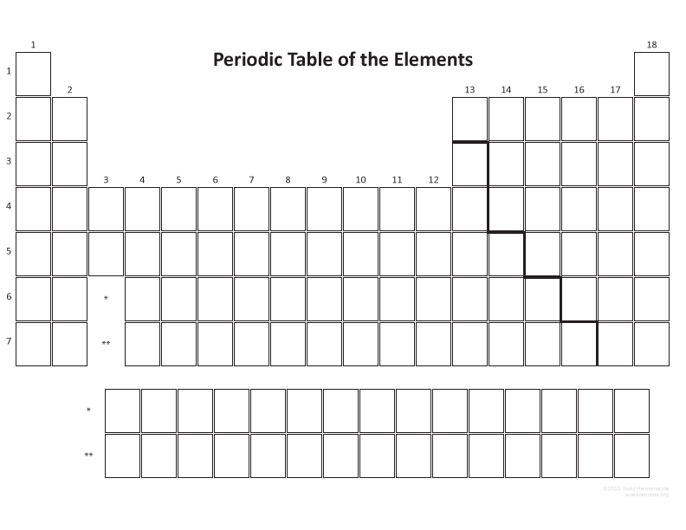

- Chemistry of the groups – Elements with similar chemical behavior are in the same groups.
  - The alkali metals (Group 1)
    - The alkali metals are:
    - Hydrogen is placed in Group 1 but is not a metal
    - The alkali metals react readily with nonmetal to give ions with a +1 charge
    - Compounds of alkali metals are common in nature and in daily life
  - The alkaline earth metals (Group 2)
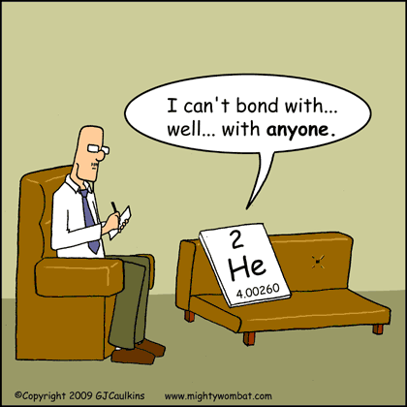
    - The alkaline earth metals are:
    - Are metals that react readily with nonmetals to give ions with a +2 charge
  - The noble gases (Group 18)
    - The noble gases are:
    - Are monatomic
    - Are unreactive gases at room temperature and pressure
    - Are call inert gases
  - The halogens (Group 17)
    - The halogens are:
    - They react readily with metals to form ions with a -1 charge.
    - They are all diatomic
- Periodic Trends within the Periodic Table - Within the periodic table, there are trends that follow certain patterns.
  - Atomic Number and Atomic Mass
    - Atomic Number goes up going from left to right and top to bottom
    - Atomic Mass follows the trend for the most part
  - Electronegativity – the ability of an atom in a molecule to attract shared electrons to itself
    - Like electron affinity – ability of an atom to attract an electron to itself to form an ion
    - As we go down the periodic table, electronegativity _____________.
    - As we go right in the periodic table, electronegativity _____________.
  - Atomic Radii - the distance from the center of an atom to the outer-most electrons
    - As we go down the periodic table, atomic radii _____________.
    - As we go right in the periodic table, atomic radii _____________. (Why?????)
      - Coulombic Attraction – attraction between positive and negative charges within an atom
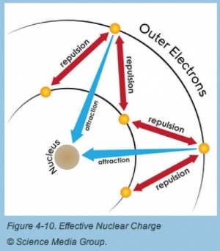
        - Depends upon:
          - Amount of charge – more charge = more attraction
          - Distance between charges – more distance = less attraction
        - As we go right in the periodic table = more attraction
          - Due to no new energy levels of electrons
            - More charges = more pull
            - Therefore, smaller size
      - Shielding Effect – Core electrons block the attractive force of the nucleus from the valence electrons
        - Therefore, distance from positive and negative charges is greater causing coulombic attraction to be less causing larger atomic radius
  - Ion Radii – the distance from the center of an ion to the outer-most electrons
    - Cations are smaller than their neutral counterparts
    - Anions are larger than their neutral counterparts
    - Why?

  - Ionization Energy – Energy required to remove an electron from an atom to form a cation.
    - Ionization energy is always positive
    - Larger values mean that the electron is more tightly bound to the atom and harder to remove
    - As we go down the periodic table, ionization energy _____________.
    - As we go right in the periodic table, ionization energy _____________. (Why???)
      - Nuclear charge – larger the charge, greater the ionization energy
      - Shielding effect – greater the shielding effect, less ionization energy
      - Radius – greater the distance between the nucleus and the valence electrons, less ionization energy
      - Sublevel – electrons from a full or half-full sublevel requires additional energy to be removed
    - As more electrons are added to an atom, they have the potential to be lost.
      - The first electron to be lost always requires energy and is known as the first ionization energy
      - The second electron to be lost always requires more energy to be removed and is known as the second ionization energy
      - The pattern continues until all electrons are lost

