- The chemical bond - attractive force between two atoms or ions that binds them together as a unit.
  - Occurs due to a redistribution of valence electrons
  - Bonds form to:
    - decrease potential energy (PE)
    - increase stability
- There are three types of primary bonds:
  - covalent bond - (prefix "co" means jointly so co-valent means jointly shared valence electrons)
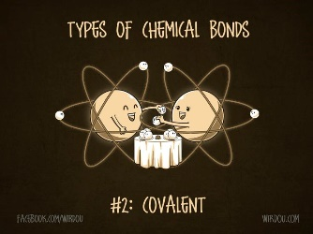
    - between non-metals
    - atoms in a covalent bond share electrons to obey the octet rule
    - Forms between atoms that have similar electronegativities
    - Compounds formed from covalent bonds are:
      - a. molecules - small (water and carbon dioxide)
      - covalent network solids - large (diamonds)
    - Lewis Dot Structures - are used to show covalent bonds between atoms.
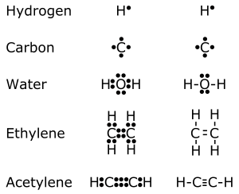
      - Steps for Lewis Dot Structures:
        - 1. Figure out how many valence electrons are possessed by each atom in the molecule and arrange them around the atomic symbol with the least number of paired electrons
        - If there are two different types of atoms, put the least electronegative atom in the center.
        - Arrange the electrons so that each atom contributes one electron to a single bond between each atom
        - Count the electrons around each atom and see if they obey octet rule. If so, they are complete.
        - If octets are not complete, continue to bond lone electrons between atoms (double and triple bonds).
    - Geometry - VSEPR Theory - Valence Shell Electron Pair Repulsion
      - Idea that electron domains want to be as far away from each other as possible.
      - Used to predict 3-D shape of molecule
      - Common structures include: (DRAW THEM!!!!!!!!!!!!!)
        - Linear
        - Trigonal Planar
        - Tetrahedral
        - Pyramidal
        - Bent
    - Hybridization - (recall the shapes of the orbitals)
      - A hybrid occurs when two things are combined and the result has characteristics of both
        - EX: hybrid car (uses gas and electricity)
      - During chemical bonding, different atomic orbitals undergo hybridization.
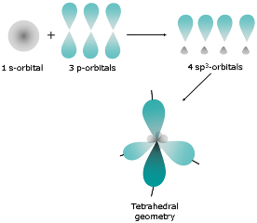
      - Consider methane, CH₄ ₋ The carbon atom has four valence electrons with the electron configuration of [He]2s²2p².
      - You may expect the two unpaired p electrons to bond with other atoms and the two paired s electrons to remain as a lone pair
      - However, carbon undergoes hybridization, a process in which atomic orbitals mix and form new, identical, hybrid orbitals.
      - With four hybrid orbitals - carbon can now make 4 bonds
      - Lone pairs can also occupy hybrid orbitals
        - dictate the shape of the molecule
        - Example: Water(Bent)
    - Valence Bond Theory
      - Hybridization is a major player in this approach to bonding.
      - There are two ways orbitals can overlap to form bonds between atoms.
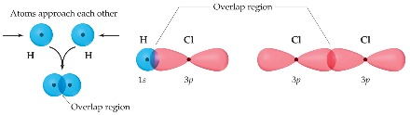
        - Sigma bonds are characterized by
          - Head-to-head overlap.
          - Cylindrical symmetry of electron density about the internuclear axis.
        - Pi bonds are characterized by
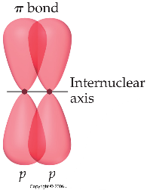
          - Side-to-side overlap.
          - Electron density above and below the internuclear axis
      - Single bonds are always σ bonds, because σ overlap is greater, resulting in a stronger bond and more energy lowering.
      - Multiple bonds
        - In a multiple bond one of the bonds is a σ bond and the rest are π bonds.
        - In a molecule like formaldehyde an sp² orbital on carbon overlaps in σ fashion with the corresponding orbital on the oxygen.
        - The unhybridized p orbitals overlap in π fashion.
        - In triple bonds, as in acetylene, two sp orbitals form a σ bond between the carbons, and two pairs of p orbitals overlap in π fashion to form the two π bonds.
      - Delocalized Electrons: Resonance
        - When writing Lewis structures for species like the nitrate ion, we draw resonance structures to more accurately reflect the structure of the molecule or ion.
        - In reality, each of the four atoms in the nitrate ion has a p orbital.
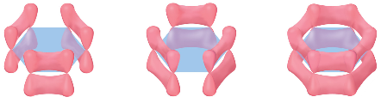
        - The p orbitals on all three oxygens overlap with the p orbital on the central nitrogen.
        - This means the π electrons are not localized between the nitrogen and one of the oxygens, but rather are delocalized throughout the ion.
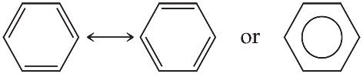
        - The organic molecule benzene has six σ bonds and a p orbital on each carbon atom.
        - In reality the π electrons in benzene are not localized, but delocalized.
        - The even distribution of the π electrons in benzene makes the molecule unusually stable.

  - Ionic Bond - an attraction between two oppositely charged particles (ions)
    - Usually occurs between metals and non-metals
    - Occurs between two particles that have different electronegativities - the larger the difference the stronger the ionic bond.
    - Formation occurs when a metal, who has a low Ionization Energy, releases some its electrons and when a non-metal gains electrons and they achieve stable electron configurations.
    - Compounds formed from ionic bonds are salts.
    - Writing Formulas of Ionic Compounds
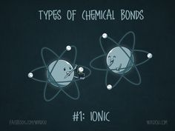
      - Chemical Formulas - shows the number of atoms in a compound and must have a neutral charge.
      - To write an ionic compound's chemical formula:
        - Find the charges of the ions involved in the salt.
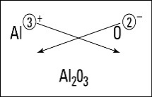
        - Criss-Cross Rule - the charge of the cation becomes the subscript of the anion and the charge of the anion becomes the subscript of the cation.

        - Make sure the subscripts are in lowest possible terms
        - If writing a salt made with a polyatomic ion, all rules are the same but if you need multiple of a polyatomic ion, you must put parenthesis around it.
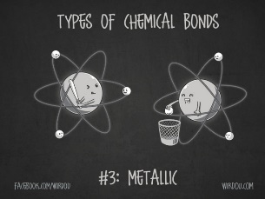
  - Metallic bond - forms between metals
    - Occurs when valence shells of metals overlap each other and allows the valence electrons to flow easily from atom to atom.
    - The attraction comes from the flow of the "conduction" electrons and the fixed positive nuclei
- Properties of each bond’s compounds

 | Covalent-Network | Ionic | Metallic | Molecule
Melting Point

Solubility

Conductivity of Solid

Hardness

Brittleness

