Unit 14 - The Gas Laws

- The atmosphere - "ocean" of different gases mixed together.
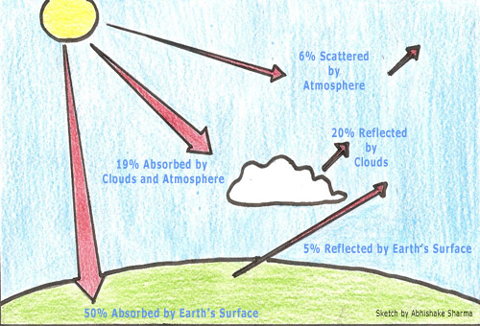
  - Composition:
    - Nitrogen (N₂) --> 78%
    - Oxygen (O₂) --> 21%
    - Argon --> 0.93%
    - Water Vapor (H₂O) --> 0.1%
    - Carbon Dioxide (CO₂) --> 0.03%
    - Trace amounts of: He, Ne, Rn, SO₂, CH₄, etc...

- The Greenhouse Effect
  - Good thing --> without it the Earth would be too cool
  - Bad thing --> too much CO₂ --> too warm
  - Why is there more CO₂ in the atmosphere?

- Depletion of the ozone layer
  - Ozone (O₃) is a charged particle that in the upper atmosphere blocks UV Rays
    - UV rays cause cancer and cataracts
    - O₃ depletion is caused by chlorofluorocarbons (CFCs)
    - Uses for CFCs included refrigerants and aerosol propellants
  - CFCs were banned in the USA and much of the world
  - Ozone is formed every time a strike of lightning occurs

- Common Units used when describing Gases
  - Temperature: K and °C
    - Conversion
      - °C = K – 273
  - Pressure: kPa, mm Hg, atm, psi
    - Conversions:
      - 1 kPa = 7.5 mm Hg
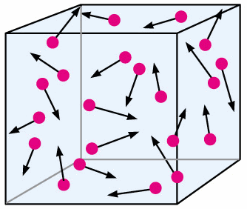
      - 1 atm = 101.3 kPa
      - 1 atm = 760 mm Hg
      - 1 atm = 14.7 psi

- The Kinetic Molecular Theory (KMT)
  - explains why gases behave as they do
  - deals with "ideal" gas particles
  - The 5 claims that the KMT makes about gases are that Air molecules:
    - are so small they are assumed to have zero volume
    - are in constant, straight-line paths
    - experience elastic collisions
    - no energy is lost
    - have no attractive or repulsive forces acting towards each other
    - have an average kinetic energy that is proportional to the absolute temperature of the gas

- Gas Pressure - A force that is exerted on an area by air molecules
  - Pressure = Force / Area P = F/A
    - If F acts on a large area - pressure is small
    - But if F acts on a small area - pressure is large
    - At Sea Level, air pressure = standard pressure
      - 1 atm, 101.3 kPa, 760 mm Hg, 14.7 lb/in²
    - Key important things about gas pressure:
      - Gases exert force in all directions
      - Atmospheric pressure changes with altitude
        - As altitude increases, pressure decreases
      - Barometer is the tool we measure pressure

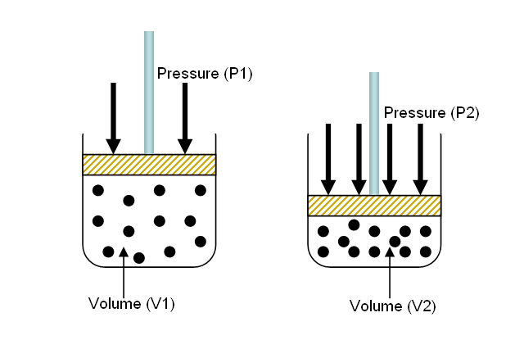
- Bernoulli's Principle
  - For a fluid traveling parallel to a surface
  - Fast moving fluid exerts Low Pressure
  - Slow moving fluids exert High Pressure

- Boyle's Law
  - The relationship between Pressure and Volume
  - At constant temperature and number of particles
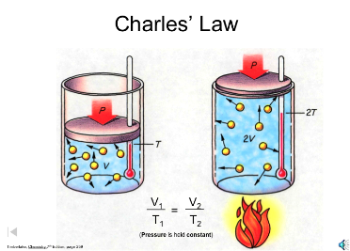
  - As pressure increases, volume decreases
  - As pressure decreases, volume increases

- Charle's Law
  - Relationship between Temperature and Volume
  - At constant Pressure and number of particles
  - As temperature increases, volume increases
  - As temperature decreases, volume decreases

- Amonton's Law / Gay-Lussac's Law
  - Relationship between Pressure and Temperature
  - At a constant volume and number of particles
  - As temperature increases, pressure increases
  - As temperature decreases, pressure decreases

- Avogadro's Law
  - Relationship between amount of gas and Volume
  - At a constant pressure and temperature
  - As amount of gas increases, volume increases
  - As amount of gas decreases, volume decreases

- The Combined Gas Law
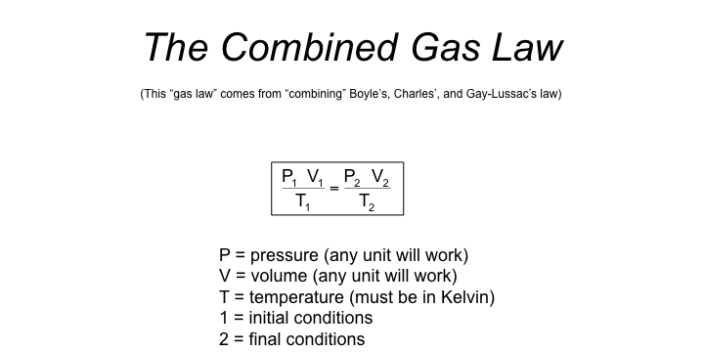
  - STP --> Temp = 0 °C or 273 K
  - Pressure = 1 atm
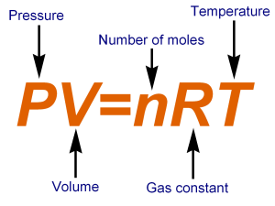
- The Ideal Gas Law
  - PV = nRT
    - P = Pressure (in kPa)
    - V = Volume (in Liters)
    - n = # of moles of gas (mol)
    - T = temperature (in K)
    - R = universal gas constant = 8.314 L-kPa/mol-K

- Gas Stoich
  - If problem is at STP, then use 22.4
  - If problem is not at STP, use ideal gas law to convert
    - Given liters of gas, start with ideal gas law
    - Looking for liters of gas, start with stoich conversion

