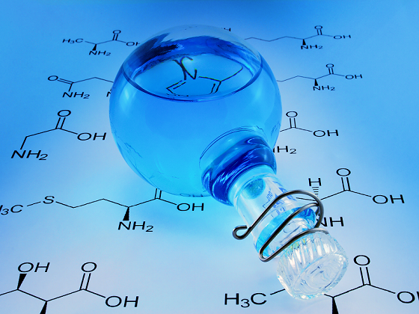
Organic Chemistry: The chemistry of carbon and carbon-based compounds

Organic Chemistry in everyday life:
    - Smells & tastes: fruits, chocolate, fish, mint
    - Medications: Aspirin, Tylenol, Decongestants, Sedatives
    - Addictive substances: Caffeine, Nicotine, Alcohol, Narcotics
    - Hormones/Neurotransmitters: Adrenaline, Epinephrine
    - Food/Nutrients: Carbohydrates, Protein, Fat, Vitamins
    - Genetics: DNA, RNA
    - Consumer products: Plastics, Nylon, Rayon, Polyester
  - Drawing Organic Structures - Butane: C₄H₁₀
    - Line Structure
      - Only shows bonds
      - C atoms assumed at each end and intersection of bonds
      - H atoms not shown
      - Assume 4 bonds to each C
      - Fulfill C’s 4 bonds by adding H’s
  - Types of Organic Compounds
    - Classified according to functional groups
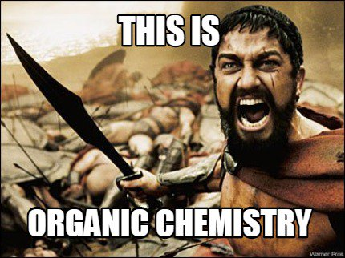
      - Alkanes
      - Alkenes
      - Alkyne
      - Haloalkane
      - Alcohol
      - Ether
      - Ketone
      - Aldehyde
      - Carboxylic Acid
      - Amine
      - Amide
      - Amino Acid
  - Big Idea in Organic Chemistry
    - Structure controls Function
- Alkanes
  - All C atoms are tetrahedral and sp³ hybridized (only C-C single bonds)
  - General formula = C_{n}H_{2n+2} (CH₄, C₂H₆, C₃H₈, C₄H₁₀, etc.)
  - Can have linear or branched alkanes
  - Same molecular formula, different structure: structural isomers
  - Branches are called substituents
  - Primary (1°) carbon atom: bound to 1 other C atom
  - Secondary (2°) C atom: bound to 2 other C atoms
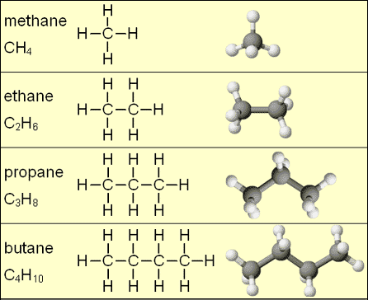
  - Tertiary (3°) C atom: bound to 3 other C atoms
  - Quaternary (4°) C atom: bound to 4 other C atoms
  - Names of Linear Alkanes and Alkyl Substituents
    - 1 carbon – methane & methyl
    - 2 carbons – ethane & ethyl
    - 3 carbons – propane & propyl
    - 4 carbons – butane & butyl
    - 5 carbons – pentane
    - 6 carbons – hexane
    - 7 carbons – heptane
    - 8 carbons – octane
    - 9 carbons – nonane
    - 10 carbons – decane
  - Naming Branched Alkanes (IUPAC)
    - Root name: name of longest continuous C chain (parent chain)
      - 2 equally long? Choose the one with more branches
    - Number C atoms in chain, starting at end with first branch
    - Identify substituents, give each a number (C it is connected to)
      - Two or more identical substituents: use prefixes (di-, tri-, tetra-, etc.)
    - List substituents alphabetically after prefix
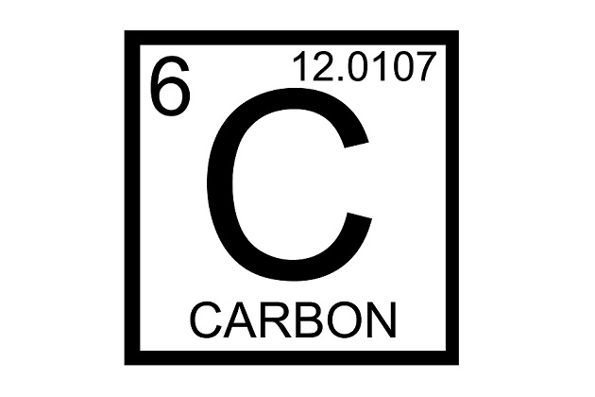
      - Do not alphabetize prefixes
    - Punctuation:
      - commas separate numbers from each other
      - hyphens separate numbers from names
      - no space between last substituent & root name

- Isomers = Two molecules that have the same molecular formula but different properties
  - Orientation of the atoms is different in each compound
  - The more carbons an alkane has, the more isomers it will have

- First Ten Hydrocarbon Properties - As number of carbons increases:
  - The boiling point increases
  - The melting point increases
    - Linear Alkanes
      - 1 - 4 C atoms: gas at room temp
      - 5 - 15 C atoms: liquid at room temp
      - >15 C atoms: solid at room temp
        - Due to:
          - Non-polar only London Dispersions Forces
          - Larger molecular weight Stronger LDPs

- Cycloalkanes - Alkanes with closed ring(s) of C atoms
  - General formula: C_{n}H_{2n} (C₃H₆, C₄H₈, C₅H₁₀, etc.)
  - Angles of alkanes need to be near 108 which makes some cyclos unstable
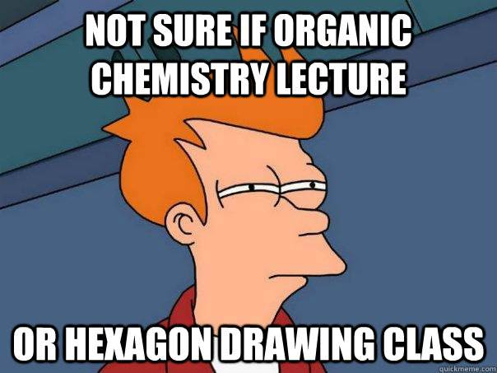
  - Naming: use cyclo- prefix before alkane name
    - Find the longest carbon chain
      - If it is in the cycloalkane – use it as the base name
      - If it is in a straight chain, the cycloalkane becomes an alkyl group
      - Name the alkyl groups coming off of the cycloalkane
      - If there is only one, numbering is not needed
      - If there are 2 or more alkyl groups
        - Place the highest alphabetical alkyl group on the 1st carbon then followed by the others.
      - In numbering the carbons, you want the sum of the numbers to be the least possible.

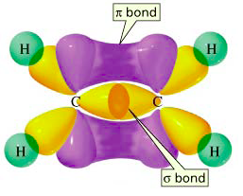
- Difference between sigma and pi bonds
  - Sigma bonds are the strongest type of covalent chemical bond. They are formed by head-on overlapping between atomic orbitals.
  - Pi bonds are not as strong and form where two lobes of one involved atomic orbital overlap two lobes of the other involved atomic orbital.

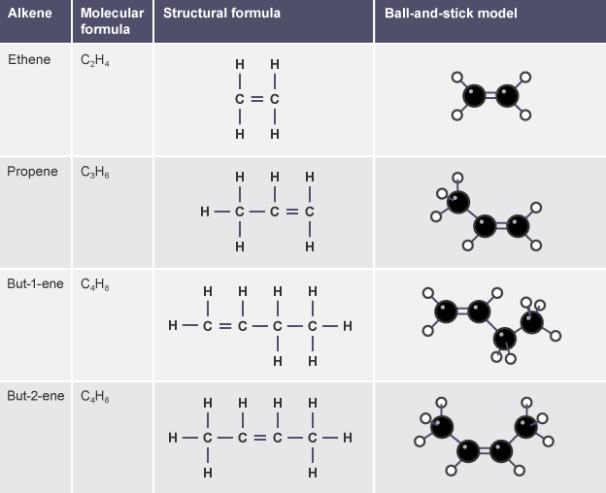
- Alkenes
  - Contain at least one C=C double bond
  - General formula: C_{n}H_{2n} (like cycloalkanes)
  - Each carbon atom in a C=C double bond is sp² hybridized
  - The double bond consists of a σ bond and a π bond
    - σ bond from head-on overlap of sp² orbitals
    - π bond from side-on overlap of p orbitals
  - A σ bond is stronger than a π bond.
  - Rotating a double bond requires breaking the π bond
    - NO FREE ROTATION at room temperature
  - Alkene Nomenclature (Naming)
    - Parent chain = longest chain that includes the double bond(s)
    - The double bonds have priority and must have the lowest number(s) possible
    - The first C atom in the C=C bond indicates the double bond’s location (or number in naming)
    - Name, number, & alphabetize substituents as usual
    - Replace –ane ending with –ene ending
      - Two double bonds: -diene; three double bonds: -triene
    - Put double bond number in front of entire root name
      - (i.e. 2-pentene indicates the double bond starts on carbon 2)
    - Cyclic alkenes: number the atoms in the ring starting with the double bond
  - Cis-trans isomerism in alkenes
    - Substituents will stay on the same or opposite sides of the double bond (no C=C bond rotation)
    - For cis-trans isomerism, each C in the double bond must have 2 different substituents attached (i.e. a C and a H, etc.)
    - Determining cis or trans: follow the parent chain through the double bond 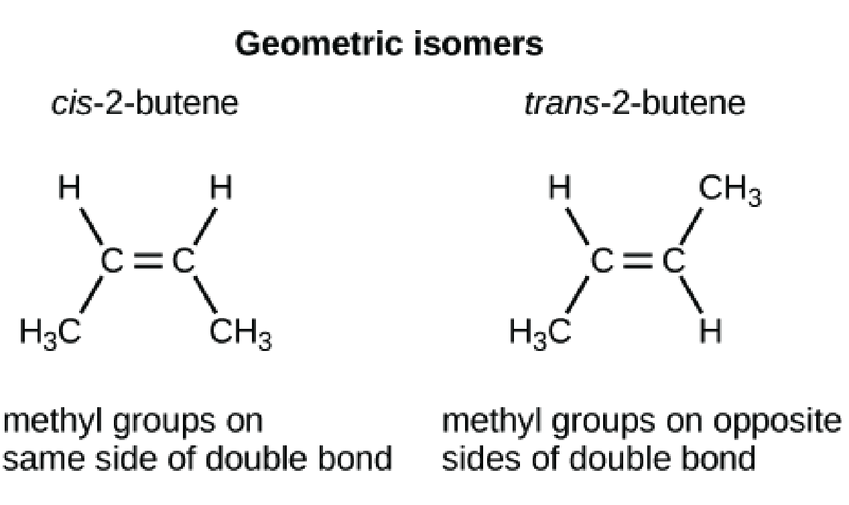
- Alkynes
  - Contain at least one C≡C triple bond with sp-hybridized C atoms
  - Triple bond: one σ bond (sp orbitals), two π bonds (p orbitals)
  - Naming: triple bond indicated by –yne ending
