1. History of Chemistry
   1. 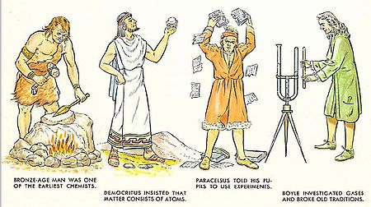The first controlled chemical reaction was fire
   2. Metallurgy – study of the physical and chemical behavior of metallic elements, intermetallic compounds, and their mixtures which are called alloys.
   3. Alchemy – the tradition of converting cheaper metals into gold.
   4. Antoine Lavoisier – Law of Conservation of Mass – mass of a closed system will remain constant over time.
2. Matter - Important Introduction Definitions
   1. Matter - anything that has mass and volume
   2. 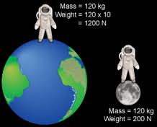Mass - the amount of matter in something
      1. the amount of "stuff" in something
   3. Law of Conservation of Mass/Matter - Matter cannot be created nor destroyed but transformed
      1. total mass of products = total mass of reactants
   4. Weight - the effect of gravity on a mass
      1. Mass does not change
      2. weight will change depending on gravitational pull
   5. Volume - the amount of space something takes up
   6. The States of Matter - solid, liquid, gas, plasma
      1. Written in order of increasing energy
3. Properties of Matter – how to describe the matter
   1. Density - how tightly packed the matter is
   2. Electrical Conductivity - how easily it conducts electricity
   3. Heat Conductivity - how easily thermal energy is transferred to, from, and through the matter
   4. Reactivity - how the matter reacts with different items
   5. Malleability - ability to hammer out matter into a shape
   6. Ductility - ability to be drawn into a wire
   7. 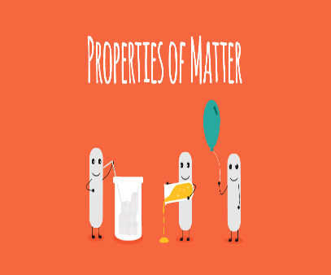Brittleness - how easily it breaks
   8. Magnetism - how attracted matter is to a magnet
   9. Melting/freezing Point - the temperature at which a solid becomes a liquid and vice versa
   10. Boiling/Condensing Point - the temperature at which a liquid becomes a gas and vice versa
4. Categories of Properties of Matter
   1. Chemical Properties - property that deals with how a substance reacts with another substance
   2. Physical Properties - property that can be observed without chemically changing the substance
   3. Extensive Property - depends upon how much of the substance you have
   4. Intensive Property - does not depend upon how much you have
5. Properties of the Elements
   1. Metals - most of the elements
      1. Usually shiny, dense, and melt at high temperatures.
      2. Shape can be easily changed into thin wires (ductile) or flat sheets (malleable)
      3. 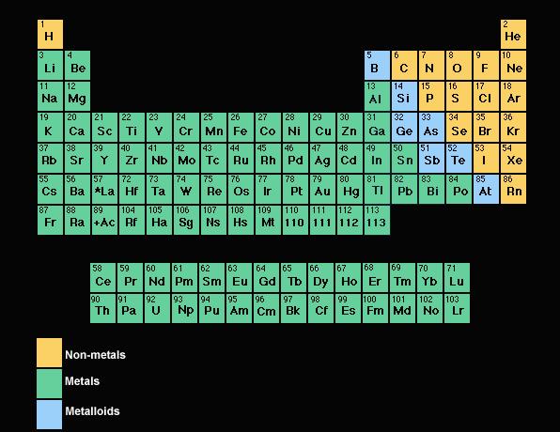Metals will corrode (reactivity)
      4. Heat and electricity travel easily through metals
   2. Non-metals – right side of the periodic chart
      1. Surface is dull
      2. Have low densities
      3. Low melting and boiling points
      4. Shape of non-metals cannot be changed because they are brittle and will break
      5. Do not conduct electricity and heat
   3. Metalloids - elements at the border of the metals and non-metals
      1. They can be shiny or dull
      2. Their shape is easily changed but also can be brittle
      3. Electricity and heat can travel through metalloids but not as easily as they travel through metals
6. Composition of Matter - what the matter is made up of
   1. Atom - basic building block of matter
      1. ~100 different types of atoms
      2. periodic table
      3. monatomic atoms - elements that consist of one un-bonded atom
         1. Ex: He, Ne, Ar, Kr, Xe, Rn
      4. polyatomic atoms - elements that consist of two or more "like" atoms
         1. diatomic atoms - O2, H2, N2, F2, Cl2, Br2, I2
      5. Allotropes - different forms of the same element in nature in the same state
   2. Compounds – contains two or more different types of atoms
      1. Have different properties from those elements in make up
      2. Compositions of compounds
         1. The Law of Multiple Proportions states that elements can combine in different ratios to form different compounds.
            1. Example: CO2 - Carbon Dioxide, CO - Carbon Monoxide
         2. The Law of Definite Proportions states that a compound has a fixed ratio of the elements it makes up.
            1. Example: CO2 = 1:2 ratio always



1. Classifying Matter



1. Mixtures - two or more pure substance mixed together
   1. have varying compositions
   2. have varying properties
   3. These substances are **NOT** chemically bonded and they retain their physical properties
      1. Example: salt water
   4. 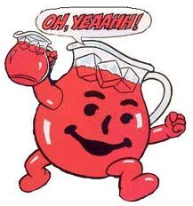Two types of mixtures
      1. homogenous mixture - solutions
         1. particles are microscopic
         2. sample has the same composition throughout
         3. sample has the same properties throughout
      2. Heterogenous mixture
         1. different compositions throughout the mixture
         2. has different properties throughout
         3. unevenly mixed
2. Separating Mixtures
   1. We can separate mixtures because each part of a mixture still has its unique properties
   2. We can separate them physically
   3. Methods of Separating Mixtures
      1. Magnet
      2. Filter
      3. Decant
      4. Evaporation
      5. Distillation
      6. Centrifuge
      7. Chromatography
3. Energy – the ability to do work
   1. 2 Types of Energy
      1. Kinetic Energy - energy of motion
         1. a. KE = 0.5mv2
         2. hot gas particles have more KE -->moving faster
         3. Temperature is a measurement of Kinetic Energy
      2. Potential Energy - stored energies
         1. chemical potential - energy stored in chemical bonds
         2. Examples: wood, fossil fuels, batteries, fats
   2. Law of Conservation of Energy
      1. Energy cannot be created nor destroyed but transformed
   3. Types of energy changes
      1. Endothermic Reaction - Energy goes into the reaction
         1. 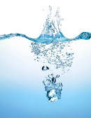Absorbs Heat
         2. Feels Cold
         3. Examples: ice getting heat from water, ammonium chloride in water
      2. 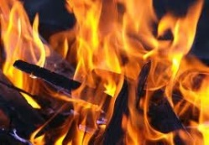Exothermic Reaction - Energy is released from the reaction
         1. Releases Heat
         2. Feels Warm
         3. Examples: burning wood, water giving heat to ice
   4. Heating Curves - Diagram that shows the temperature changes of a substance.
      1. Flat regions show phase changes
         1. Change in PE (molecular rearrangement)
         2. Temperature remains constant
         3. **Heat of Fusion** (**ΔHfus**) - Energy required to melt 1 gram of a substance at its melting point
         4. **Heat of Vaporization** (**ΔHvap**) - Energy required to boil 1 gram of a substance at its boiling point
            1. ΔHvap is much larger than ΔHfus
      2. 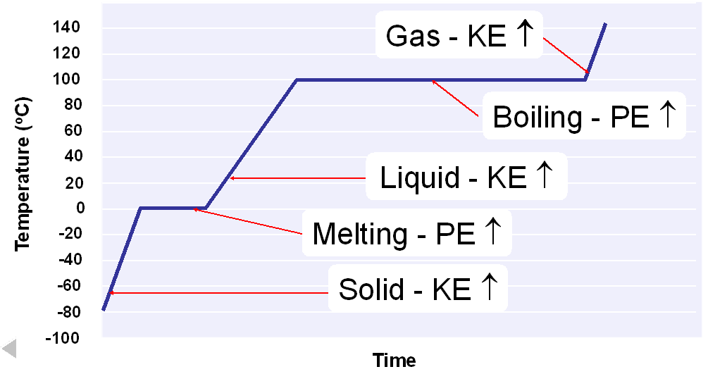Steep areas show increase in temperature
      3. Temperature Change
         1. Change in KE (molecular motion)
         2. Depends upon the specific heat
      4. Specific Heat
         1. Energy required to raise the temperature of 1 gram of a substance 1oC.
         2. Different types of substances transfer energy at different rates
         3. Ex: Liquid Water = 4.18 J/g x K Solid Silver = 0.235 J/g x K
   5. Energy calculations
      1. Calculations involving specific heat (temperature change)
         1. **q = s . m . ΔT**
         2. q = heat lost or gained (J)
         3. -q = heat lost
         4. +q = heat gained
         5. s = specific heat (J/g . °C)
         6. m = mass (g)
         7. ΔT = Temperature Change = Tf - Ti (°C)
      2. Calculations at phase changes (no temperature change)
         1. For substances at freezing/melting point
            1. q = ΔHfus .m
         2. For substances at condensing/boiling point
            1. q = ΔHvap .m
      3. Calculations involving two materials
         1. When comparing two objects at different temperatures, you simply use the same equation but set them equal.
         2. qobject 1 = - qobject 2
         3. The reason for the negative sign is the gain of energy for the first object is the release of energy of the second.
      4. Example: You have 15.75g of Iron and it absorbs 1086.75 J of heat energy. The temperature raises from 25oC to 175 oC. What is the specific heat of iron?
      5. Example: How much energy does it take to heat water from -10 oC to 45 oC?
      6. Example: 125g of water is initially at 25.6 °C. A 50g sample of iron at 115 °C is added to the water. If the specific heat of water is 4.184 J/(g °C) and iron's is 0.453 J/(g °C), what is the final temperature of both the iron and water?