- Ionic compounds - cation and anion combinations
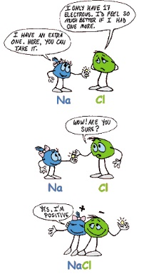
  - Single-charge cations with elemental anions
    - The single charge cations include:
      - groups 1, 2, 13, Ag¹⁺, and Zn²⁺
    - To name, given the formula: NaCl
      - Use name of the cation: (Sodium)
      - Use the name of the anion dropping the ending and add -ide: (Chloride)
        - Ex: NaCl = Sodium Chloride
    - To write the formula, given the name: Calcium Iodide
      - Write the symbols for the two ions: Ca²⁺ and I¹⁻
      - Balance the charges to write the formula.
    - Note: the names that end in -ide are talking about a specific element, the names that do not are usually talking about a polyatomic ion.
  - Multiple-charge cations with elemental anions
    - The multiple charge cations include:
      - Pb²⁺/Pb⁴⁺, Sn²⁺/Sn⁴⁺, transition metals (except Ag and Zn)
      - Need to know roman numerals for this
      - To name, given the formula: FeO
        - Figure out the charge of the cation
          - (you know the charge of the anion) --> Fe? and O²⁻
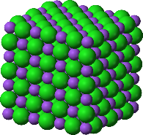
        - You know the ratio of Fe to O is 1:1 and the charge of O is 2 negative, then Fe must be 2 positive.
        - Write the name of the cation: Iron
        - Write roman numerals in ( ) to show the charge of the cation: Iron (II)
        - Write the name of the anion with -ide ending
        - FeO = Iron(II) Oxide
      - To find the formula, knowing the name: Cobalt(III) Chloride
        - write the symbols of the ions: Co³⁺ and Cl¹⁻
        - balance the charges to write the formula
- Covalent compounds – non-metals
  - between non-metals - forget the charge
  - What to do:
    - Use Greek prefixes to indicate how many atoms of each element.
      - If the first type of atom only has one atom, mono is not needed.
    - The last element ends in -ide.
- Acid nomenclature
  - binary acids - acids with hydrogen and one other element
    - How to name, given the formula:
      - write the prefix "hydro"
      - write the prefix of the other element followed by "-ic acid"
    - How to write the formula, given the name:
      - write the atomic symbols of the atoms in acid
      - the charge of the other element tells you how many hydrogens you need
  - oxy-acids - acids containing hydrogen, oxygen, and another element
    - common oxyanions: (NO₃)¹⁻, (PO₄)³⁻, (SO₄)²⁻ , (CO₃)²⁻
      - polyatomic ions that contain oxygen combine with hydrogen to form oxyacids
    - How to name, given the formula:
      - write the prefix of the oxyanion followed by "-ic acid"
    - How to write the formula, given the name:
      - write the atomic symbols of the atoms in acid
      - the charge of the oxyanion tells you how many hydrogens you need

