- Kinetic Molecular Theory (KMT) - According to the KMT, the state of a substance at room temperature depends upon the strength of the attractions between its particles.
  - Attractive forces in solids are stronger than that of liquids which are stronger than gases.
    - Movement:
      - solids --> vibrations
      - liquids --> can flow short distances
      - gases --> can flow long distances

- Different types of Compounds - The physical properties of solids, such as hardness, electrical and heat conductivity, and melting point, depend upon the kind of particles that make up the compound and on the strength of the attractive forces between them.
  - Ionic Compounds
    - Involves the transfer of electrons and typically form between metals and non-metals
    - The organization of the charge particles make the substance quite strong
    - All ionic compound are solids at room temperature
    - They are hard yet brittle
    - Poor Conductors of Heat and Electricity
    - However, they are great conductors in water. (Why?)
  - Metallic Compounds
    - The particles in metallic solids are atoms but the forces that bind these atoms together are the forces of attraction between the mobile valence electrons and the fixed positive metal ions.
    - Almost all metallic compounds are solids at room temperature (mercury being the exception)
    - They are malleable and ductile
    - Great Conductors of Heat and Electricity
  - Molecular Compounds
    - Form between non-metals and involve the sharing of electrons
    - Covalent bonds are strong, BUT the interaction between molecules is quite weak
    - Gases and liquids are exhibited by molecules
    - They are relatively soft and have low melting points
    - Typically, are not good Conductors of Heat and Electricity
  - Covalent Network solids
    - Sometimes covalent bonds do not form molecules but long "networks" of covalent bonds
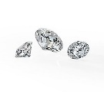
    - Solids at room temperature
    - They are very hard and have high melting points
    - Typically, are not good Conductors of Heat and Electricity

- Solids
  - Properties of all solids:
    - particles in the solid state are highly ordered and remain in fixed positions
    - distances between particles are comparable for liquids and solids (very close to one another)
    - almost all solids exhibit some form of crystalline structure
  - Crystalline Solids
    - crystal structure - the total three-dimensional arrangement of particles of a crystal - the overall shape of the crystal
    - Unit cell - the smallest portion of a crystal lattice that shows the three-dimensional pattern of the entire lattice
      - cubic - (a.k.a. isometric) - all sides of equal length
      - tetragonal - 2 sides of equal length and 3rd side different length
      - hexagonal - characterized by having 60/90 degree angles
      - rhombohedral - (a.k.a. trigonal) - all sides equal and all angles equal but none are 90º
      - Orthorhombic - characterized as having all angles of 90º and all sides of unequal length
      - Monoclinic - characterized by having a rectangular base (90º angles) and in the shape of a parallelogram
      - triclinic - characterized by having 3 sides of unequal length and 3 different angles which are not 90º
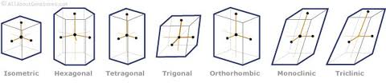
  - Amorphous Solids - Greek for "without-shape"
    - Forms with rapid cooling of molten minerals
    - Prevents the formation of crystals
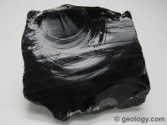
    - Some do not consider amorphous solids to be solids but rather super cooled liquids
      - The viscosities are high enough to prevent liquid flow
      - The particles become trapped in the disordered arrangement that is characterized by liquids.
    - Examples: Glass and Obsidian

- Intramolecular Forces vs. Intermolecular Forces
  - Intramolecular forces are the forces that exists inside the molecule.
    - The prefix 'intra' means within or inside
    - Considered to be the primary bonds
    - Does not determine the physical state of the matter.
    - Ex: Ionic and Covalent
  - Intermolecular Forces are the forces that exist between molecules.
    - The prefix 'inter' means between or among
    - Considered to be secondary bonds
    - Whether a substance is a solid, liquid, or gas depends upon the strength of the forces between molecules
    - Compared to the primary bonds, these are substantially weaker
  - Need to know terms to understand intermolecular forces:
    - Polarity --> how electrons are shared
    - Non-Polar molecules share electrons evenly
    - Polar molecules do not share electrons evenly
    - a molecule with a dipole is a molecule with a positive and negative region
      - - δ+ or δ- refers to the partial charge of that portion of the molecule
  - The following intermolecular forces are in order of strength from weakest to strongest
    - London Dispersion Forces
      - is the weakest of the intermolecular forces
      - acts between atoms and molecules
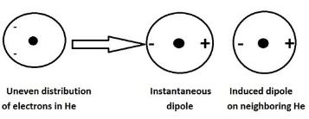
      - is a temporary attractive force that results when the electrons in two adjacent atoms occupy positions that make the atoms form a temporary attraction to each other
      - they are the reason why very weak molecules are attracted to each other despite being non-polar
      - this allows non-polar items to condense to liquids and solids at low enough temperatures

    - Induced Di-Pole Forces (Debye Force)
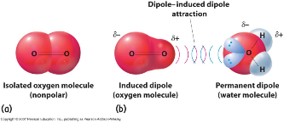
      - is stronger than London Dispersion Forces but weaker than di-pole - di-pole forces
      - happens between a molecule with a permanent dipole on one molecule which induces a dipole on another
      - Can be expected between any polar molecule and non-polar molecule
    - Dipole-Dipole Forces
      - stronger than induced di-pole but weaker than hydrogen bonds
      - interaction between two molecules with permanent dipoles (polar molecules)
      - These interactions tend to align the molecules to increases the attraction
    - Hydrogen Bonding
      - is the strongest of the intermolecular forces
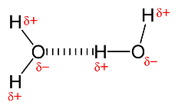
      - is the attraction between a lone pair of electrons on an electronegative atom and a hydrogen atom that is bonded to either a nitrogen, oxygen, or fluorine
      - hydrogen bonds are responsible for the high melting point of water
      - hydrogen bonds are partly responsible for the secondary, tertiary, and quaternary structures of proteins and nucleic acids.
- Liquids
  - Liquids are Fluids
  - substance that can flow and therefore take the shape of their container
  - Properties
    - Liquids have relatively high density
    - 10% less than solids (average)
      - H₂O the exception
    - Liquids are relatively incompressible
      - the volume doesn't change much when pressure is applied
    - Liquids have the ability to diffuse
      - liquids diffuse and mix with other liquids
    - Surface Tension - the resistance of a liquid to change its shape at the surface
      - high intermolecular forces = greater surface tension
    - Capillary Action
      - Cohesive forces act between liquid molecules
      - Adhesive forces between polar liquid molecules and polar bonds in the material making up the container
        - Water's adhesive forces are greater than its cohesive forces
        - This is why there is a meniscus of water in graduated cylinders.
        - oxygen in glass is attracted to H in H₂O
  - Why is water so special?
    - Due to the strong hydrogen bonds in water (4 possible for 1 molecule)
    - Surface tension is greater --> stronger than normal
    - Capillary Action --> why it was stronger with water alone
    - High melting point --> no other molecule with such a small molar mass has so high freezing/melting point
    - The unit cell structure of water is hexagonal
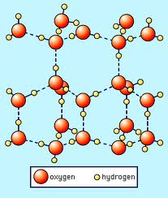
      - this structure gives opportunity for air pockets to form thus making the density less due to air having a lower density.
    - Summary of water's properties:
      - Bond Type - Polar
      - Density of ice - 0.917 g/cm³
      - Boiling Point - 100ºC
      - Density of water - 0.999 g/cm³
      - Melting Point - 0ºC

 | Gas | Liquid | Solid
Compressible

Density

How it fills a container

Fits the container

Diffusion

Expansion when heated

